**Tutorial 12**

**ECSE104L**

Q1. Design circuit for the given state diagram using T flip flop.

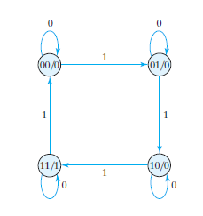

Q2. Design circuit for the given state diagram using D flip flop.

